

**FINAL EVALUATION**

**COMMON EMITTER AMPLIFIER**

A report submitted to the

Department of Electrical and Information Engineering

Faculty of Engineering

University of Ruhuna

Sri Lanka

On 19 th April 2024

In completing an assignment for the module

EE4152 Electronic Project

By

|  |  |
| --- | --- |
| EG/2021/4424 | : BALASOORIYA J.M |
| EG/2021/4426 | : BANDARA |
| EG/2021/4432 | : BANDARA K.M.T.O.N |
| EG/2021/4433 | : BANDARA L.R.T.D |

**Content**

1. Introduction 7

1.1 Introduction 7

1.2 Problem Statement 7

1.3 Objectives 8

1.4 Methodology 9

2. Calculations 11

3. Implementation Of The Final Circuit 13

3.1 Proteus schematic Circuit 13

3.2 PCB Layout of the Circuit 14

3.3 3D View in PCB Layout 14

4.Results and Discussion 15

5.References 17

**List Of Figures**

Figure 1: 2N3904Transistor 8

Figure 2:Schematic Figure of the circuit 13

Figure 3: PCB Layout 14

Figure 4:3D view in PCB Layout 14

Figure 5: Frequency Response of the Proteus 15

**List of Table**

Table 1: Property Table 2N3904 Transistor 10

**Abstract**

Among the three types of BJT amplifiers, the common emitter configuration is widely used. BJT amplifier due to its high voltage and current gain. The fundamentals and characteristics of the common emitter BJT amplifier are explained in detail. This abstract explores the key aspects of the common emitter. The amplifier circuit is engineered to provide desired voltage gain, impedance, and bandwidth while operating within specified supply voltage and current constraints. We include design methodology, component selection criteria performance analysis of the amplifier.

To obtain the required performance, component selection includes choosing appropriate transistors, biasing resistors, coupling and bypass capacitors, and load resistors. Linear amplification and steady transistor performance is ensured by proper biasing. The frequency response and signal coupling properties of the amplifier are also affected by the choice of capacitor.   
  
To evaluate the design and optimize performance parameters, theoretical analysis and simulations are carried out. Through the use of theoretical calculations and modeling tools, the voltage gain, input and output impedance, bandwidth, distortion, and stability of the amplifier are assessed.   
  
In the end, the amplifier design is built and put through experimental testing to confirm that it meets all of the requirements. Validation of the attained voltage gain, frequency responsiveness, distortion levels, and other important performance criteria is done by measurement.

All things considered, this project provides a thorough process for creating a Common Emitter BJT amplifier that satisfies particular performance requirements. The design procedure, component selection, simulation, and experimental validation are all covered in the abstract, which provides information on how BJT amplifiers are actually employed in a variety of applications.

**Preface**

we are pleased to be present for the completion of the report of BJT amplifier designing which is the combination of the complexity and the creativity through out of this journey under the module of EE 4105- Electronic Project. This report is concluding not merely a collection of the pages but it is a moasis insights each page thoughtfully constructed by the dedication of the team and the guidance by the steady hands of our lecturers,

Through the blend of the detailed project and collaborative discussion project is focused about the BJT amplifier design for specific gain & bandwidth. This project provides a through analysis of BJT amplifier design which supported by detailed research and data analysis.

Finally we thank our lecturer and peers for their valuable guidance and the feed back making this not just a report, but a symphony of student collaboration and engineering insight.

**EE4152: Electronic Project**

**Emitter BJT Amplifier (Gain=; Bandwidth=;)**

# **Introduction**

## Introduction

The creation of a circuit that can increase an input signal while satisfying particular performance requirements is the process of designing a Common Emitter Bipolar Junction Transistor (BJT) amplifier. The fundamentals of BJT amplifiers, the significance of the common emitter configuration, and the design goals are described in this introduction.   
  
Bipolar junction transistors are semiconductors that are often used for switching and amplification in electronic circuits. The common emitter setup differs from the other setups by its high voltage gain and adaptability in amplifier construction. The base terminal is biased with a DC voltage, the collector terminal acts as the output, and the emitter terminal is grounded in this arrangement.

Transistor selection based on characteristics including frequency response and current gain, together with the selection of load resistors, biasing resistors, coupling, and bypass capacitors, are important design considerations. These elements affect the gain, distortion, stability, and frequency response of the amplifier.   
  
Before a practical implementation, component values are optimized and the amplifier's performance is predicted through simulations using tools such as protease software. After the design is complete, the amplifier is built and put through experimental testing to make sure it meets all of the requirements.

## Problem Statement

Design a Common Emitter Bipolar Junction Transistor (BJT) amplifier to meet the following specifications:

Gain: 155

Bandwidth: 6.5 MHz

The amplifier should operate from a single DC power supply voltage and be constructed using standard discrete components. The design should ensure stability and low distortion across the specified bandwidth. Additionally, input and output impedance values should be compatible with typical signal sources and loads. The objective is to create a robust amplifier circuit that achieves the desired gain and bandwidth while meeting these criteria.

## Objectives

* We get a really good understanding about the working principles of our transistors,like knowing when they are on or off and how they change electrical signals.
* figure out how much we want the amplifier to boost the signal and be able to do it.
* choose the appropriate passive elements including resistors,capacitors to optimize biasing.stability and frequency response.
* implementing bias strategies (fix bias,emitter bias,collector feedback) bias to maintain the transistors optimal operating point.
* Develop a detailed schematic diagram of BJT amplifiers using proteus , incorporating selected components and biasing arrangement.
* simulate amplifier circuit to anticipate performance characteristics ,including voltage gain,frequency response and distortion levels.
* visualize PCB layout in 3D to optimize component placement,routing and thermal management.
* construct BJT amplifier circuit on physical breadboard or PCB ,following design specification .
* calibrate and adjust components as necessary to achieve optimal gain,bandwidth and stability.
* Evaluate the real- world efficiency of the amplifier,comparing its performance against simulation prediction.
* analyze discrepancies between simulation result and experimental finding ,identify potential sources of error opportunities for optimization.
* document test procedure,measure data and observation to support the final evaluation and provide insights for future design.

## Methodology

**define amplifier objective**

* conduct extensive literature review to understand BJT operation.
* clearly define goals for amplifier.(gain and bandwidth)

**component selection**

* analyze BJT datasheets and select suitable transistors based on our parameters.
* choose compatible passive elements to align with BJT and meet design objectives.

**biasing strategy development**

* establish the transistor Q point on DC trajectory.
* Stability and minimal signal distortion by selecting suitable biasing components.

**Design Execution**

* create a detailed BJT amplifier schematic using proteus software.
* calculate components values for amplifier design formula adjusted for real world applicability.

simulation phase

* Utilize proteus simulation suite.
* predict outcomes gain,frequency and impedance behavior.

**circuit construction**

* Materialize design on breadboard.
* match component specification diligently.

**final result**

* converge findings into a succinct report.
* include visual aids and performance analysis.

**Transistor Selection**

Here there two NPN Transistors are going to be used.

1. 2N3904(NPN)
   1. 2N3904(NPN) A diagram of a chip and a collector

      Description automatically generated

Figure 1: 2N3904Transistor

Table 1: Property Table 2N3904 Transistor

|  |  |
| --- | --- |
| Continuos Collector Current | 200mA |
| DC Current Gain- min | 100 |
| Input Capacitive (Cbe) | 8 pF |

# **Calculations**

First assuming that IC =2mA,VCE=5V,β= 150

$\frac{V_{CC}}{2}$ $≥$ $V_{CE}$

$V_{CC}$ = 12V

Find IE value

$\frac{I_{C}}{β}$ = IB

IE = IC

= 2.01mA =2mA

RE =

= =13Ω

Gain =155;

RC = AVxrE =155X13 =2K

Calculate RE value;

RE =

= =1.5KΩ

Find R1 and R2 values

VB = VBE + VE

= 0.7+2X1.5

= 3.7V

$≈$ 4V

$\frac{R2}{R1+R2}$ = $\frac{4}{12}$

R2 =1KΩ & R1 = 1.5KΩ

Then Find C1/Take the starting frequency as 200 HZ

REQ1 = 0.45KΩ

CC1(C1) =

= 1.8µF

REQ2 = 2KΩ

CC2(C3) =

= 0.33µF

REQ3 = 12Ω

CE (C2) =

= 47µF

Calculating C;

C(C4) =

= 10pF

# **Implementation Of The Final Circuit**

## 3.1) Proteus schematic Circuit

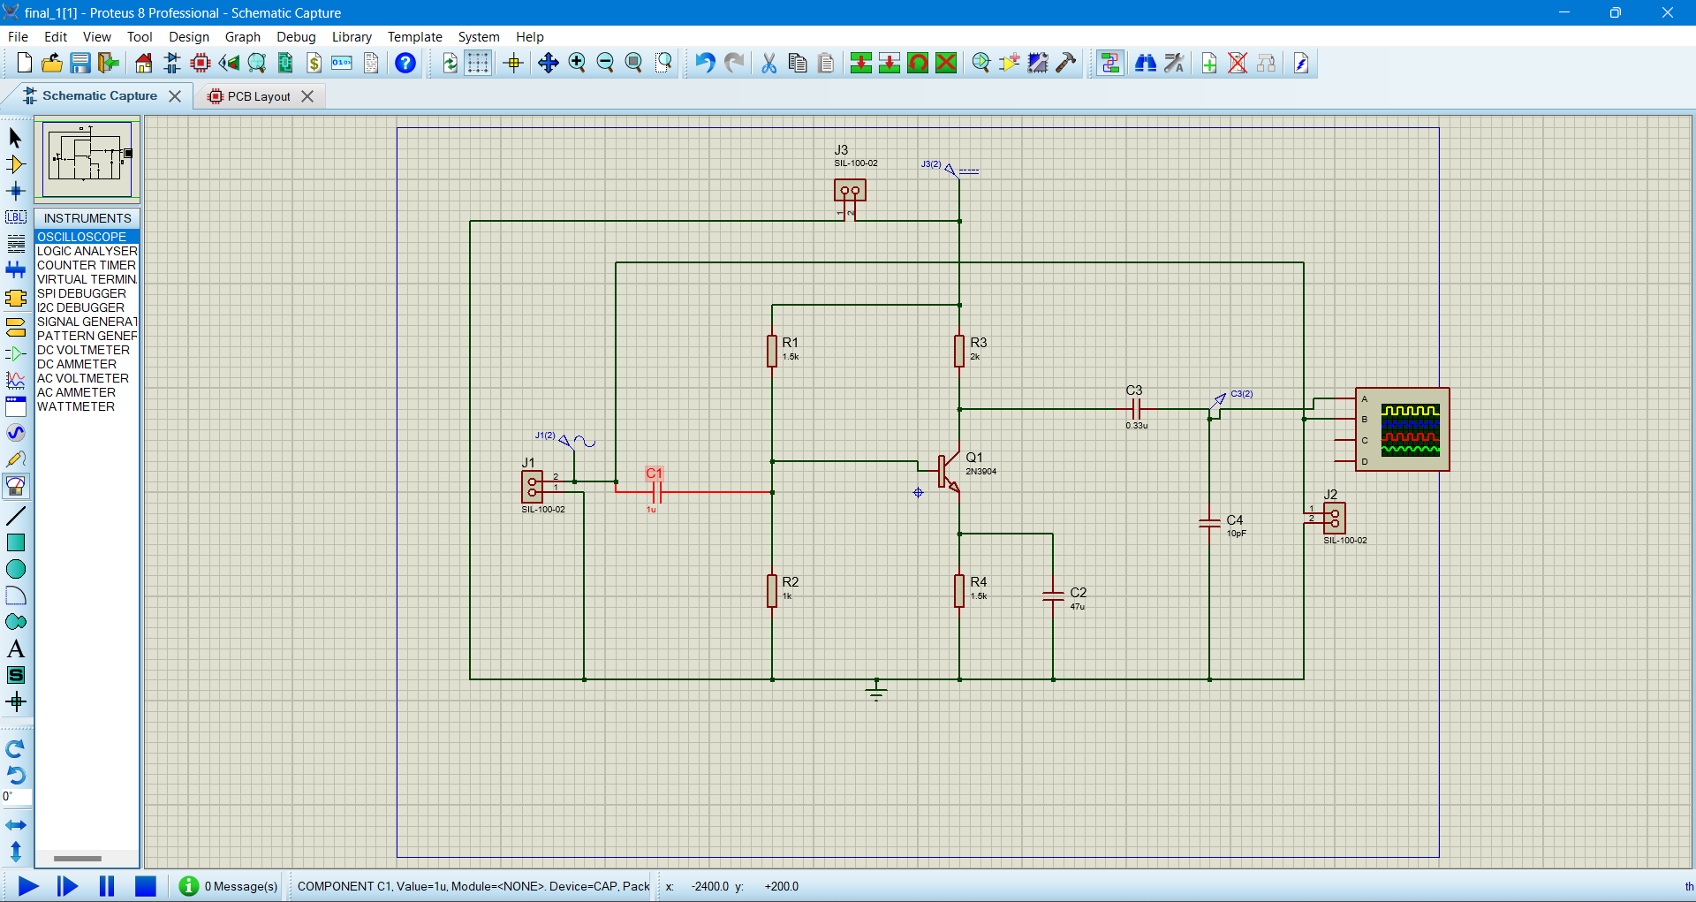

Figure 2:Schematic Figure of the circuit

## 3.2 PCB Layout of the Circuit

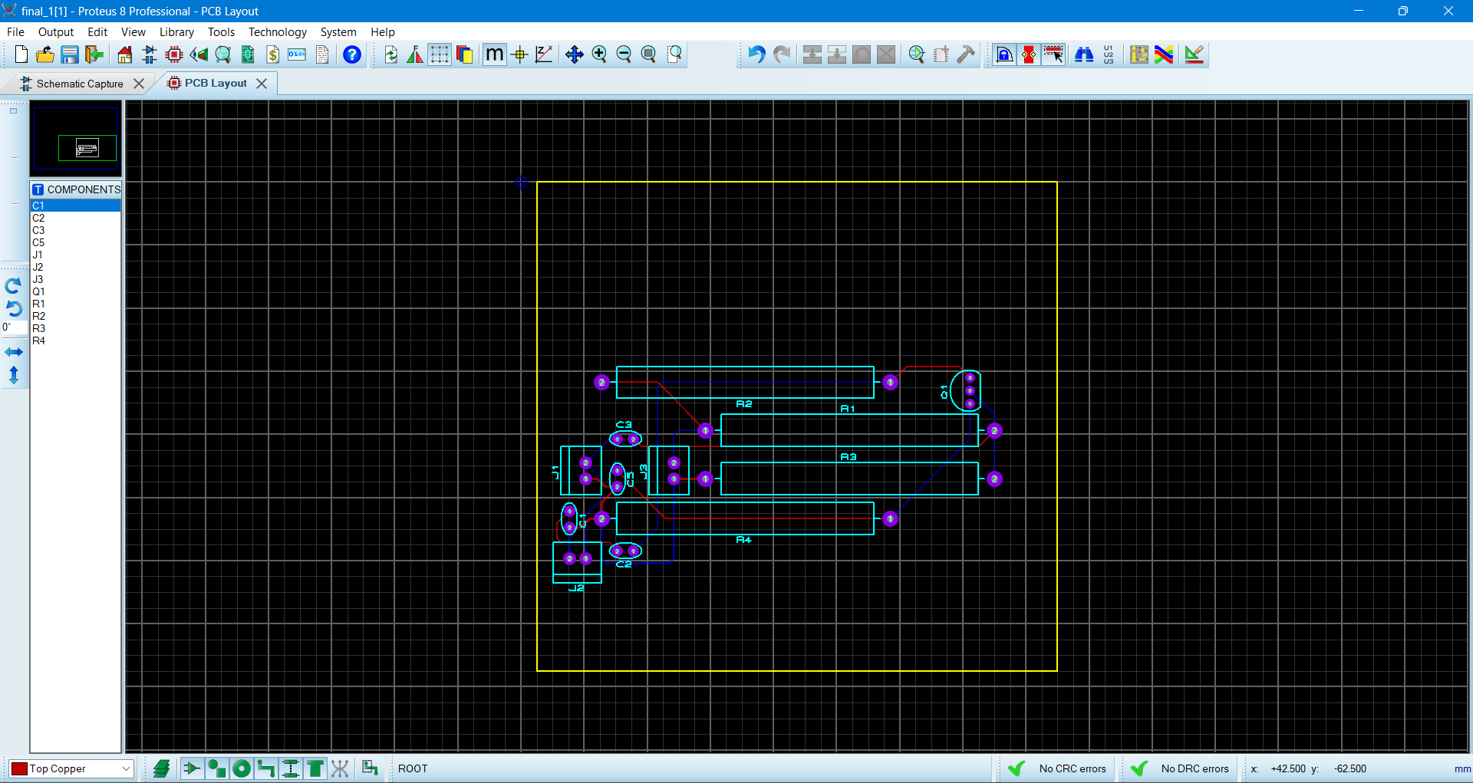

Figure 3: PCB Layout

## 3.3 3D View in PCB Layout

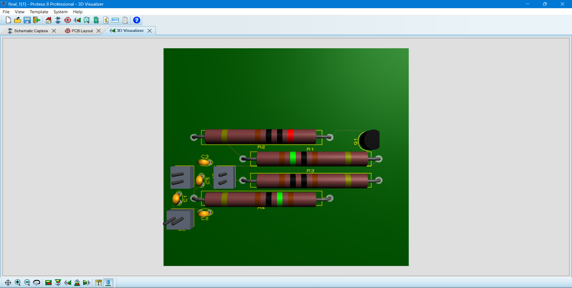

Figure 4:3D view in PCB Layout

# 4. **Results and Discussion**

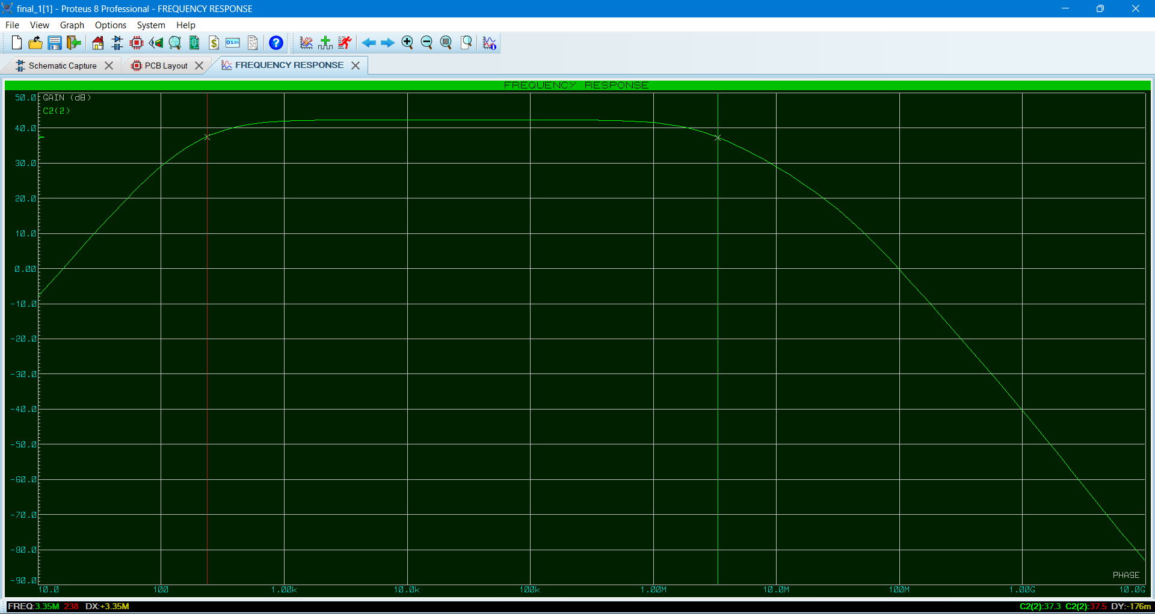

Figure 5: Frequency Response of the Proteus

From the observations:

Pass band gain = 41.5dB

Higher Cutoff Frequency = 5.9MHZ

Lower cutoff frequency = 283Hz

Bandwidth = 6.1MHZ-283Hz

= 6.0MHz

**Discussion**

Considering about the Proteus design and the theoretical calculations it is clear that has get the values are looks same. From the frequency graph we have get the gain as 41.5Db

Gain = 20log(155)

= 43.80

So there is a small difference between them.

Not only that but also there is a small difference between the theoretical and experimental values of the bandwidth also. For that it can be effects many reason one of the reasons are, when we calculating the values then the values that we determined they were not ideal. So we have to find the corresponding standard values for that. From that there is a difference between them. When we doing the practically also there are differences because of the many reasons. That are model accuracy that means as an example 2N3904 transistor that has some limitation and that will be effect to the behavior where the biasing points. As well as the temperature effects also can be happen because when doing those practical the temperature goes to increase and they effects to the semi conductor characteristics. Not only that but also there can be happen problem with grounding and power supplying when we simulating. As well as we has used the non ideal capacitors and the resistors so that there can be has behaviors of unexpected from the calculations.

# **5.References**

|  |  |
| --- | --- |
| [1] | ]"RF cafe," [Online]. Available: https://www.rfcafe.com/references/electrical/capacitor-values.htm. |
| [2] | "Basic Electronic Tutorials," [Online]. Available: https://www.electronics-tutorials.ws/amplifier/amp_2.html. |
| [3] | "Analog Devices," [Online]. Available: https://www.analog.com/en/resources/analog-dialogue/studentzone/  studentzone-july-2020.html#:~:text=Common%20Emitter%20Amplifier%20Topology&text=Capacitor%20CE%20is%20an  Common%20emitter%20BJT%20amplifier.. |
| [4] | "Cadence," [Online]. Available: https://resources.system-analysis.cadence.com/blog/msa2021-common-emitter-transistor-amplifier-design. |
| [5] | "You Tube," [Online]. Available: https://www.youtube.com/watch?v=mv7Y0A9YeUc. |